**Creating a Database Using MongoDB and Mongosh**  **Database Setup and Collection Creation**

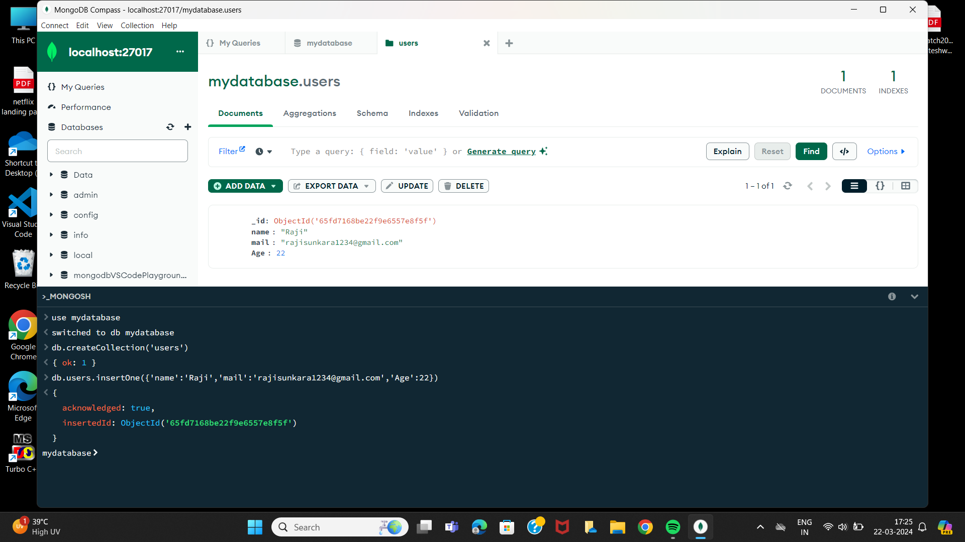

**Document Insertion**

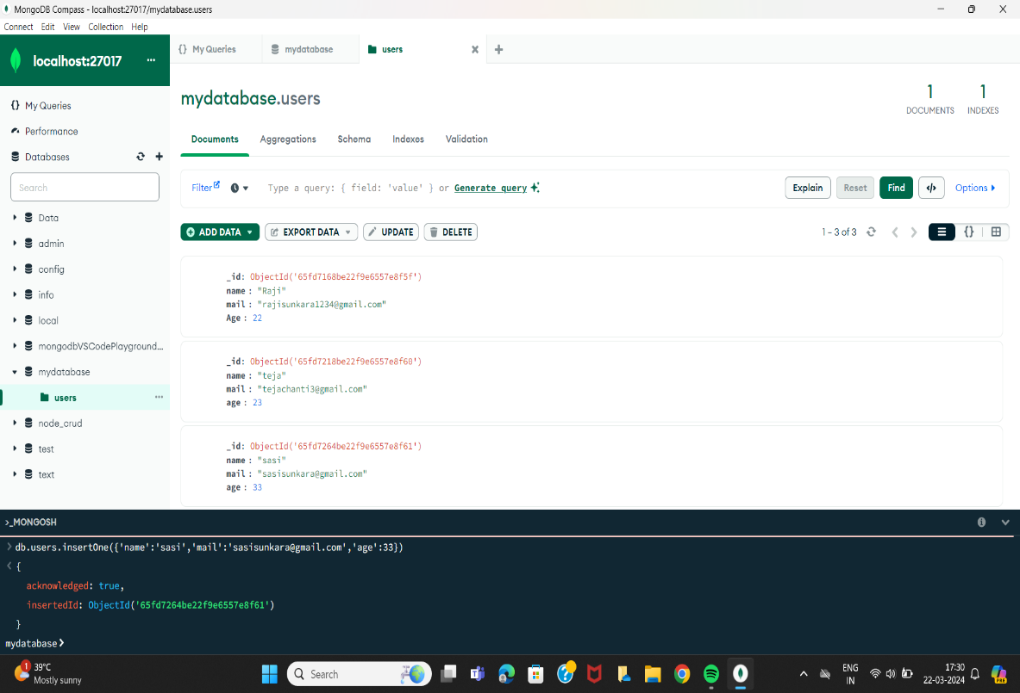

**Document updating**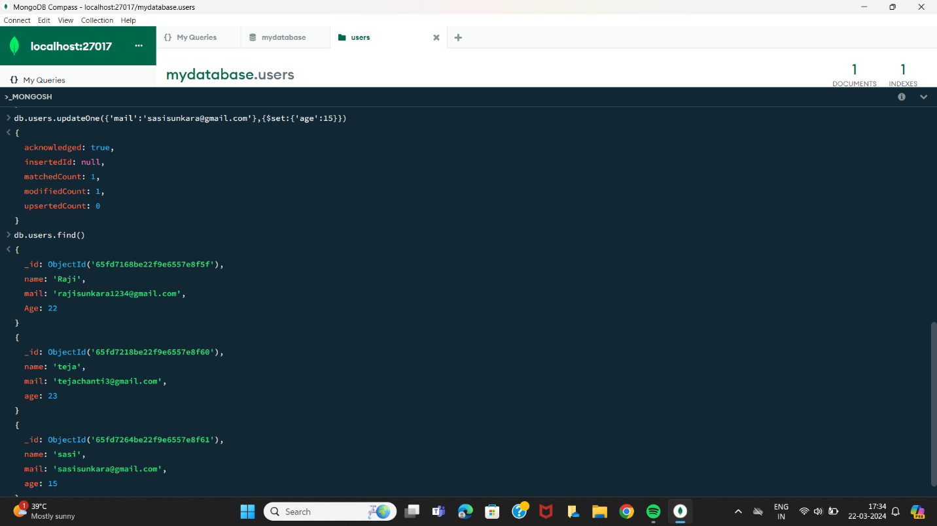

* **Deletion Operation**

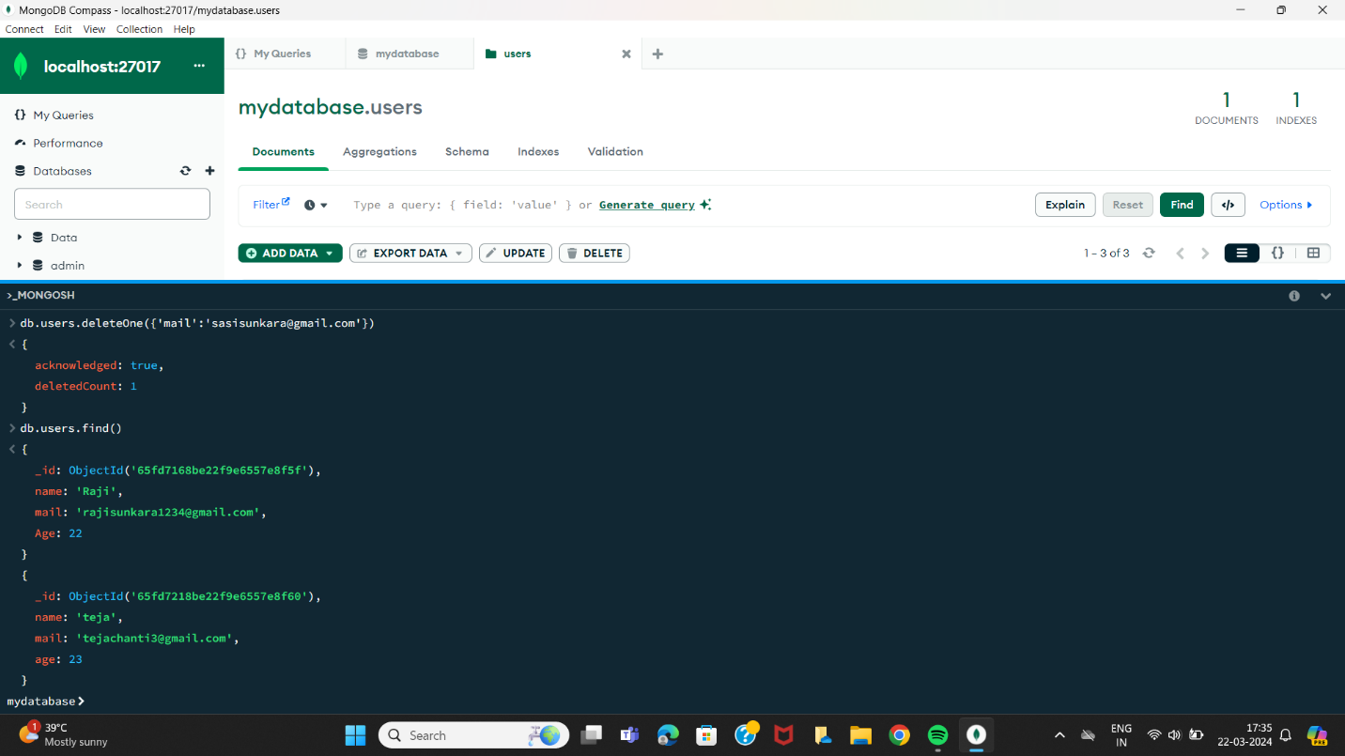

* **Index creation**

